**Project Management**

Assessment Two

**Full Name: Arthur Leonard LESMANA Student ID: 18780**

**WELLS INTERNATIONAL COLLEGE**

|  |  |  |  |
| --- | --- | --- | --- |
| Name of Student | Arthur Leonard LESMANA | ID | 18780 |

**Assessment 2 – Research (Online)**

Contents

**Instructions: 1**

**Duration: 2**

**Multiple-choice Questions: 2**

**Learning Notes: 10**

**What is a project? 11**

**Please put your learning notes here: 12**

**Project management basic 12**

**Project management History 12**

**Project management in the future 13**

**Project Team 13**

**Document Search Index 14**

## Instructions:

This is an individual assessment. Answer all the questions on the document provided by your Trainer.

## Duration:

Trainer will set the duration of the assessment.

## Multiple-choice Questions:

1. What advice do we give about factoring in the commitments of project stakeholders when making your own plans? 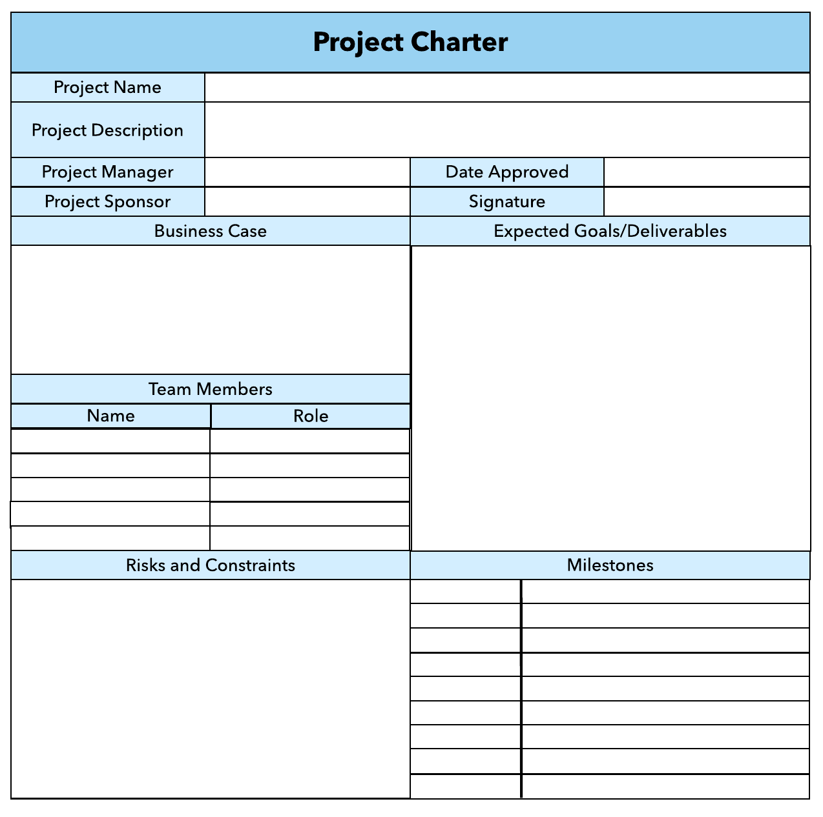
   1. Consult student timetables to see when they might be free to attend data collection sessions.
   2. Ask external organizations what the most convenient times would be for you to visit
   3. Neither of these

**d) Both A and B**

Comment: your plan needs your stakeholders know before implantation.

Web ref: <https://sustainet.com/managing-stakeholder-commitments/>

**My Comment: Prioritizing stakeholder commitments isn't just a project management best practice; it's a strategic imperative for achieving project success. By recognizing the value of stakeholders' time and resources and integrating their commitments into our planning processes, we pave the way for smoother execution, stronger collaboration, and ultimately, superior outcomes.**

1. Which of the following are essential components of a GANTT chart used to plan your project?
   1. Your home telephone number
   2. Your supervisor’s home telephone number
   3. The email address for the chair of the ethics committee
   4. **None of the above**

Comment: in order to get right or good Gantt Char, you need keep concern time, cost, scope and quality. So will get the good requirement and write good Gantt Char.

**My Comment: Tasks or Activities, Timeline, Bars or Blocks, Dependencies, Milestones. These components collectively provide a visual representation of the project schedule, allowing project managers and team members to track progress, identify potential delays, allocate resources effectively, and communicate project timelines to stakeholders.**

Web ref: <https://www.proofhub.com/articles/gantt-charts>

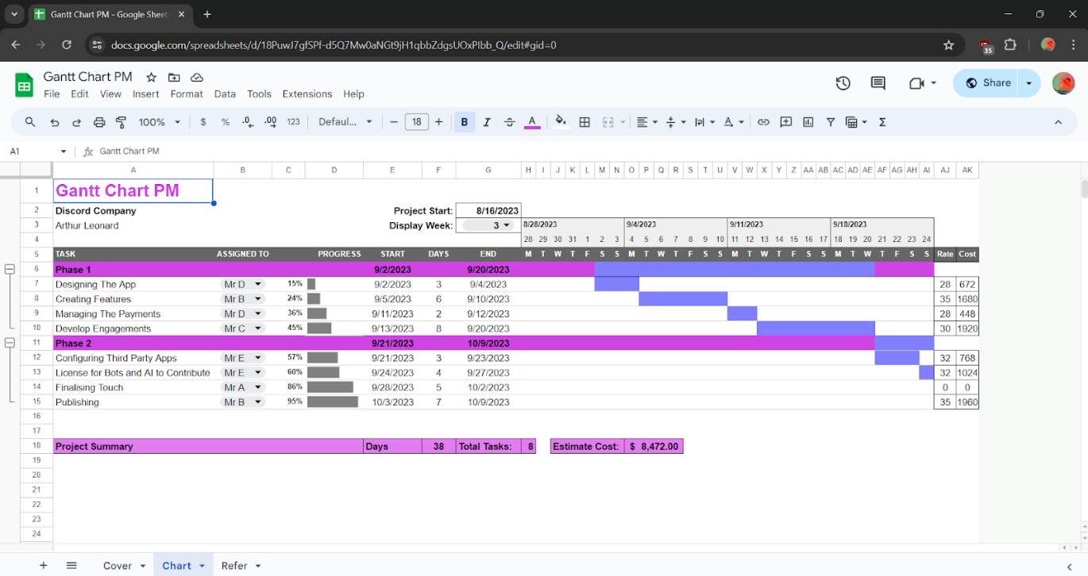

1. The intended outcome of strategy/projects integration is
   1. Clear organization focus
   2. Best use of scarce organization resources
   3. Improved communication across projects and departments
   4. Both A and C are correct
   5. **A, B, and C are all correct**

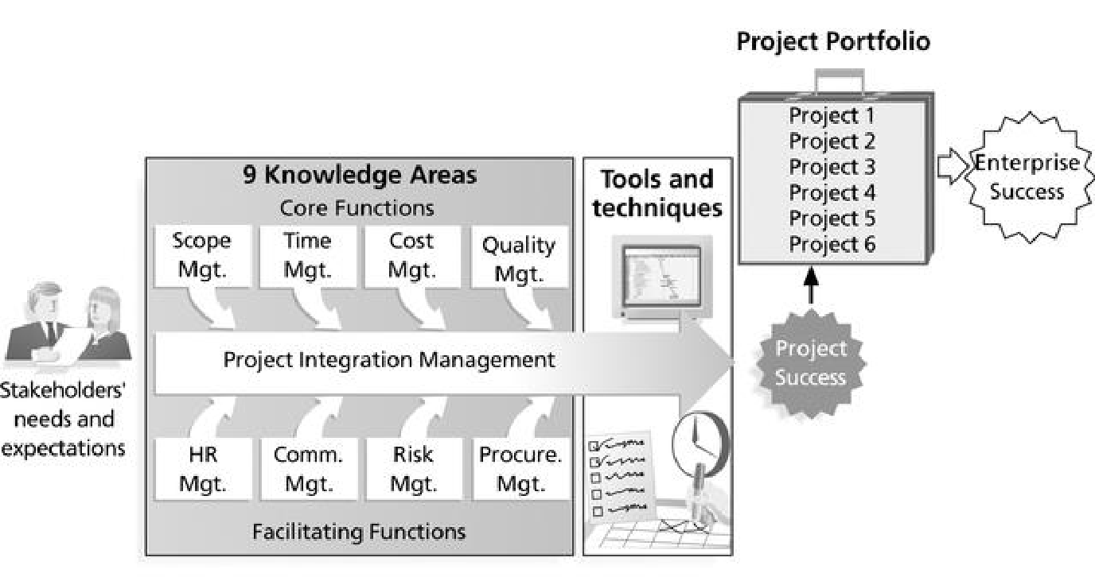

Comment: **Integration** management is a collection of processes required to ensure that the various elements of the **projects** are properly coordinated. It involves making trade-offs among competing objectives and alternatives to meet or exceed stakeholder needs and expectations.

**My Comment: In essence, the outcome of strategy/project integration is a cohesive and harmonized approach to organizational development, where projects serve as vehicles for executing strategic vision and driving sustainable growth and success.**

Web Refer: <https://en.m.wikibooks.org/wiki/Project_Management/PMBOK/Integration_Management>

1. Which of the following questions does the organization's mission statement answer?
   1. What are our long-term strategies?
   2. What are our long-term goals and objectives?
   3. How do we operate in the existing environment?
   4. **What do we want to become?**
   5. All of these are answered by the mission statement

**My Comment: While the mission statement may touch upon elements of long-term strategies, goals, objectives, and operations within its wording, its core purpose is to define the organization's reason for existence, its values, and its overarching aspirations. Therefore, while the mission statement might indirectly address aspects of long-term strategies, goals, and operations, its primary focus is on articulating the organization's fundamental purpose and direction.**

1. Which of the following is not one of the requirements for successful implementation of strategies through projects?
   1. Allocation of resources
   2. Prioritizing of projects
   3. Motivation of project contributors
   4. Adequate planning and control systems
   5. **All of these are requirements**

**My Comment: While allocation of resources, prioritizing of projects, motivation of project contributors, and adequate planning and control systems are indeed essential components for successful strategy implementation through projects, the statement "All of these are requirements" is not accurate. There could be scenarios where one or more of these requirements might not be applicable or might be outweighed by other factors depending on the specific context of the organization and its projects. Therefore, it's important to evaluate each requirement independently to ensure its relevance and necessity for a particular strategy implementation effort.**

1. Which of the following is the reason(s) why project managers need to understand their organization's mission and strategy?
   1. To make appropriate decisions and adjustments
   2. To be effective project advocates
   3. To be able to get their job done
   4. **Both A and B are correct**
   5. A, B, and C are all correct

**My Comment: Additionally, being familiar with the organization's mission and strategy helps project managers become effective advocates for their projects. They can articulate how their projects contribute to the organization's strategic objectives, gaining support and resources from stakeholders. While it's true that understanding the organization's mission and strategy helps project managers to get their job done effectively (option C), this statement is a more general observation and not directly related to the specific reasons outlined in options A and B. Therefore, option C is not as precise in addressing the reasons why project managers need to understand their organization's mission and strategy.**

1. Which of these is the highest priority and first strategy required for any organizational change?

**a) Communication**

* 1. Stress management
  2. Negotiation
  3. Learning
  4. Employee involvement

**My Comment: Effective communication is essential for successfully implementing organizational change. It ensures that all stakeholders are aware of the reasons behind the change, the expected outcomes, and their roles in the process. Clear and transparent communication helps to minimize uncertainty, reduce resistance, and build support for the change among employees. Without effective communication, other strategies such as stress management, negotiation, learning, and employee involvement may struggle to be implemented successfully. Therefore, prioritizing communication is key to laying a strong foundation for organizational change initiatives.**

1. Which of the following is not a procedure to obtain an understanding risk in the planning stage (described in ISA 315):
   1. Inquiries of management
   2. Analytical procedures
   3. Observation and inspection
   4. **Procedures for sampling audit tests**

**My Comment: Inquiries of management, analytical procedures, and observation and inspection are all common methods used during the planning stage to gather information and understand the risks associated with an audit engagement. These procedures help auditors assess the entity's internal control environment, identify potential areas of risk, and plan the nature, timing, and extent of further audit procedures.**

1. Assessment of control risk includes three steps. Which of the following is not one of these steps?
   1. Obtaining an understanding of internal controls and documentation of the controls
   2. **Evaluate sufficiency and appropriateness of audit evidence**
   3. An initial assessment and response to assessed risk based on the design of internal controls resulting in an audit planning memorandum and audit plan
   4. A final assessment based upon test of controls of operating effectiveness

**My Comment: "Evaluate sufficiency and appropriateness of audit evidence" is a broader concept that applies throughout the audit process, not specifically to the assessment of control risk. It encompasses the evaluation of all audit evidence gathered, including evidence related to control testing, substantive testing, and other audit procedures.**

1. Which of the following are not common internal control documentation techniques used by auditors?

a) Questionnaires

* 1. **Company internal control manuals**
  2. Narrative descriptions
  3. Check lists

**My Comment: The technique that is not commonly used by auditors for internal control documentation is "Company internal control manuals." While questionnaires, narrative descriptions, and checklists are commonly used by auditors to document internal controls, company internal control manuals are specific to individual organizations. These manuals are internal documents created by the company to document their internal control procedures, policies, and guidelines. While auditors may review and reference these manuals during their assessment of internal controls, they are not typically used by auditors as a primary documentation technique. Instead, auditors often rely on their own documentation methods such as questionnaires, narratives, and checklists to document their understanding of internal controls during an audit.**

1. Overall response to assessed risk may include:
   1. Identify the absence of key controls (where controls are lacking)
   2. Identify existing controls
   3. **Incorporating additional elements of unpredictability in the selection of further audit procedures to be performed**
   4. Determine potential material misstatements that could result

**My Comment: Assessing risk comprehensively involves a multifaceted approach aimed at ensuring the integrity and reliability of financial information. Firstly, it necessitates identifying any glaring absence of key controls where they should exist, thereby pinpointing potential areas vulnerable to errors or fraud.**

1. Action plan Should be 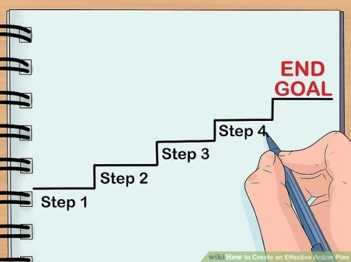
   1. Specific
   2. **Countable**
   3. Realistic
   4. Achievable

**My Comment: By adhering to this structured action plan, the organization can systematically address the absence of key controls in the accounts payable process, setting realistic targets, and taking tangible steps towards enhancing financial integrity and reducing the risk of material misstatements.**

Comment: An **action plan** is a detailed **plan** outlining actions needed to reach one or more goals. Alternatively, businessdictionary.com defines an **action plan** as a "sequence of steps that must be taken, or activities that must be performed well, for a strategy to succeed".

Web Refer: <https://en.wikipedia.org/wiki/Action_plan>

1. Which of the following is not a function of Project Management Tool?
   1. Plan a project
   2. Manage Tasks
   3. Manage Issues
   4. Time Tracking
   5. **None of above**

**My Comment: The correct answer is "None of the above." All the options listed—Planning a project, Managing tasks, Managing issues, and Time tracking are indeed functions typically performed by project management tools. They are essential aspects of project management software that help teams organize, execute, and track their projects efficiently.**

1. John, the project manager for the ERP Project, is about to complete the project phase review. The completion of a project phase is also known as which of the following?

a) A lesson learned

* 1. **A kill point**
  2. Earned value management
  3. Conditional advancement

**My Comment: The completion of a project phase is often referred to as a "kill point." This term signifies a stage where the project undergoes evaluation to determine whether it should continue to the next phase or if it should be terminated for various reasons such as feasibility, alignment with goals, or resource constraints. It's a critical decision-making point in project management.**

1. Which of the following is not a key stakeholder in a project that creates a service internal to an organization?
   1. The project manager
   2. **External customers**
   3. Project vendors
   4. Project team members

**My Comment: The key stakeholder that is not typically involved in a project that creates a service internal to an organization is "External customers." In this scenario, since the service is internal to the organization, external customers would not directly participate as stakeholders in the project. The project manager, project vendors, and project team members would be the primary stakeholders involved in such a project.**

1. Managing a project is best described as which one of the following?
   1. Establishing direction
   2. Functional controls over the project team and stakeholders
   3. **Consistently producing key results expected by stakeholders**
   4. Motivating and inspiring the project team to produce results that are expected by project stakeholders

**My Comment: Managing a project is best described as "Consistently producing key results expected by stakeholders." This definition encompasses the core responsibility of a project manager to ensure that the project delivers the desired outcomes within the specified constraints of time, budget, and scope, meeting the expectations of stakeholders. While elements of establishing direction, implementing functional controls, and motivating the team are also crucial aspects of project management, the primary goal is to achieve the project's key results as expected by stakeholders.**

1. You are the project manager for your organization. Influencing your organization requires which of the following?
   1. An understanding of the organizational budget
   2. Research and documentation of proven business cases
   3. **An understanding of formal and informal organizational structures**
   4. Positional power

**My Comment: This understanding helps project managers navigate the complex network of relationships, hierarchies, and communication channels within the organization. While an understanding of the organizational budget and research/documentation of business cases can be valuable, they are not necessarily central to influencing the organization.**

1. What is the difference between a standard and a regulation?
   1. Standards are mandatory; regulations are not.
   2. Standards are optional; regulations are not.
   3. Regulations and standards are essentially the same.
   4. **Regulations are usually mandatory; standards may be seen as guidelines.**

**My Comment: Regulations are legally binding requirements set by authorities, such as governments or regulatory bodies. Compliance with regulations is typically mandatory, and failure to comply can result in legal consequences.**

1. Which of the following is an example of a deliverable at the end of the requirements-gathering phase in a software design project?
   1. Responsibility matrix creation
   2. Detail design document
   3. **Business needs**
   4. Project team assembled

**My Comment: During the requirements-gathering phase, the focus is on understanding and documenting the business requirements, user needs, and functional specifications of the software to be developed. Therefore, identifying and documenting the business needs is a key deliverable of this phase. This documentation serves as the foundation for subsequent phases of the project, such as design, development, and testing.**

1. At what point in a project would a kill point be acceptable?
   1. When a project team member is not performing as planned
   2. **When a project reaches the end of a project phase**
   3. When a project reaches the end of its budget
   4. When a project manager determines the project team cannot continue

**My Comment: At the end of each project phase, there is usually a review or evaluation to assess whether the project should proceed to the next phase or be terminated. This assessment considers factors such as the project's alignment with objectives, budget, schedule, quality, and feasibility. If the project fails to meet certain criteria or if it no longer aligns with the organization's goals, a decision may be made to terminate the project at that phase, making it a suitable point for a kill point.**

1. Of the following, which is not an exit criterion?
   1. Customer sign-offs
   2. Quality metrics
   3. **Stakeholder analysis**
   4. Regulatory inspections

**My Comment: Stakeholder analysis, while important for understanding the interests, expectations, and influence of stakeholders throughout the project, is more of an ongoing process rather than a specific criterion for exiting a project phase.**

1. At which point is the risk of failure the least but the consequence of failure the highest?

a) During the early stages

* 1. During the middle stages
  2. **During the final stages**
  3. Risk of failure is even across all project phases

**My Comment: During the final stages of a project, much of the work has already been completed, and the project is nearing completion. At this point, the remaining tasks are often critical to the overall success of the project, such as final testing, integration, and deployment. If something goes wrong or if there are significant issues during these final stages, the consequences can be severe because there may be limited time or resources available to address them before the project is supposed to be delivered.**

1. In project estimation, project manager has to provide an expert judgement, which are considered of the following EXCEPT:
   1. Impact of inflation over the project lifecycle
   2. Required labour and labour rates
   3. Material costs and assumptions
   4. Costs of quality
   5. All of above
   6. None of above

**My Comment: In project estimation, expert judgment is indeed utilized to consider factors such as:**

* **Impact of inflation over the project lifecycle**
* **Required labor and labor rates**
* **Material costs and assumptions**
* **Costs of quality**

**Therefore, "None of the above" would be the correct choice, as all of these factors are typically considered in project estimation when providing expert judgment.**

1. Which component is/are included in Quality Management Plan
   1. Quality objectives 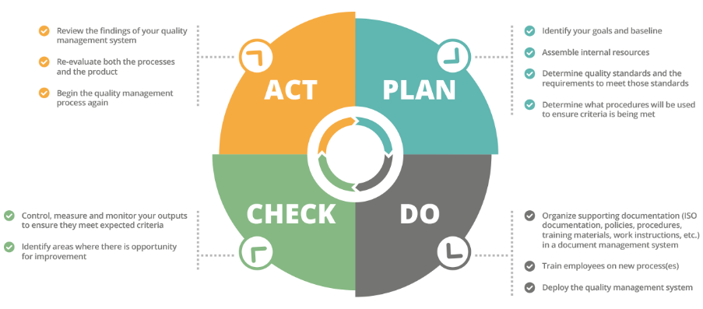
   2. Key project deliverables
   3. Quality standards
   4. Quality control and assurance activities
   5. **All of above**

**My Comment: Together, these components form the Quality Management Plan, which outlines how quality will be planned, managed, and assured throughout the project lifecycle. By defining quality objectives, specifying quality standards, identifying key deliverables, and implementing quality control and assurance activities, the Quality Management Plan helps ensure that the project meets the required level of quality and ultimately achieves its objectives.**

Comment: The four main components of a quality management process are Quality Planning, Quality Assurance, Quality Control and Continuous Improvement.

In order to get the best outcome, we need good quality management process.

Web Refer: <https://info.docxellent.com/blog/main-components-quality-management>

Web Comment: When broken down, [quality control management](https://docxellent.com/document-control-solutions/quality-management/) can be segmented into four key components to be effective: quality planning, [quality control](https://docxellent.com/document-control-solutions/change-control/), [quality assurance](https://docxellent.com/service-support/software-quality-assurance/), and quality improvement.

1. What's an activity sequencing
   1. The process for identifying and documenting dependencies among schedule activities 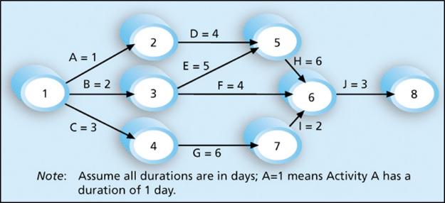
   2. The process for identifying critical activities
   3. **The process for identifying ordering and schedule activities**
   4. The process for planning the project

**My Comment: Activity sequencing is the process for "identifying ordering and scheduling activities" in a project. It involves determining the logical relationships between project activities and establishing the sequence in which they need to be performed to achieve project objectives efficiently.**

***Activity sequencing*** reviews all activities in the WBS with the goal of identifying relationships between them and classifying all the timing relationships among tasks. These relationships (aka "linkages", "dependencies", "predecessors"). Task timing relationships are important because they control task sequencing and task start and end dates. There are four types of task relationships:  
A ***finish-to-start relationship***

A ***start-to-start relationship***

A ***finish-to-finish relationship***

A***start-to-finish relationship***

Refer: <https://www.e-education.psu.edu/geog871/l5_p4.html>

Comment: activity sequencing could help make your project stage very clear and easy to follow the project progress. The process for identifying and documenting dependencies among schedule activities

## Learning Notes:

<https://www.youtube.com/watch?v=rBSCvPYGnTc&t=1323s>

A project is something extremely useful for people that want to accomplish their future ideas.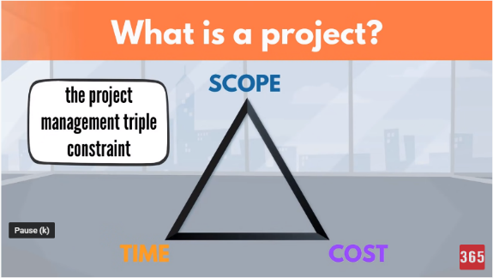

A project is a temporary endeavour undertaken to create a unique product, service or result.

Day to day activities have no end date.

Project on the other hand have a strict expiry date.

Project output is product or service or result.

Project shows different scope.

If the scope is not unique, this is a regular business process.

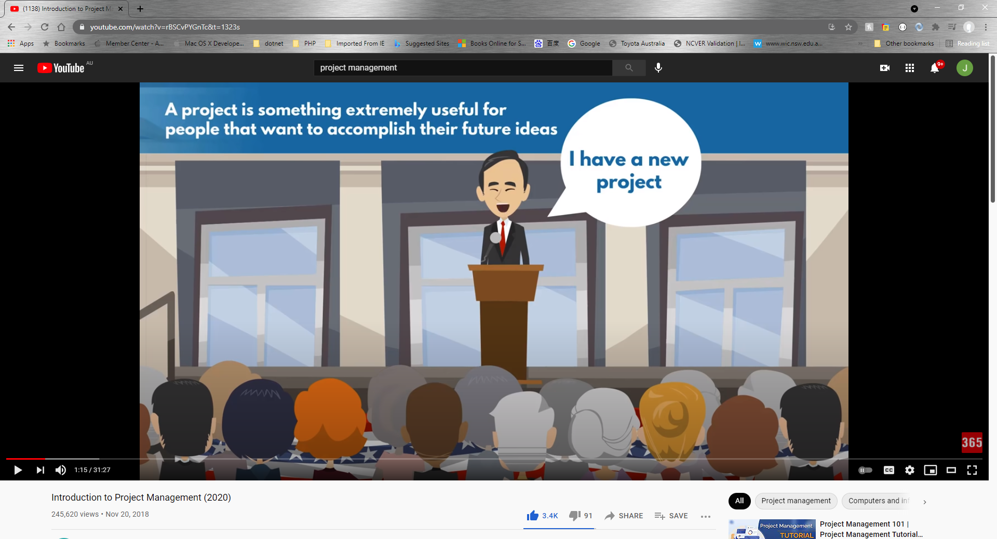

## What is a project?

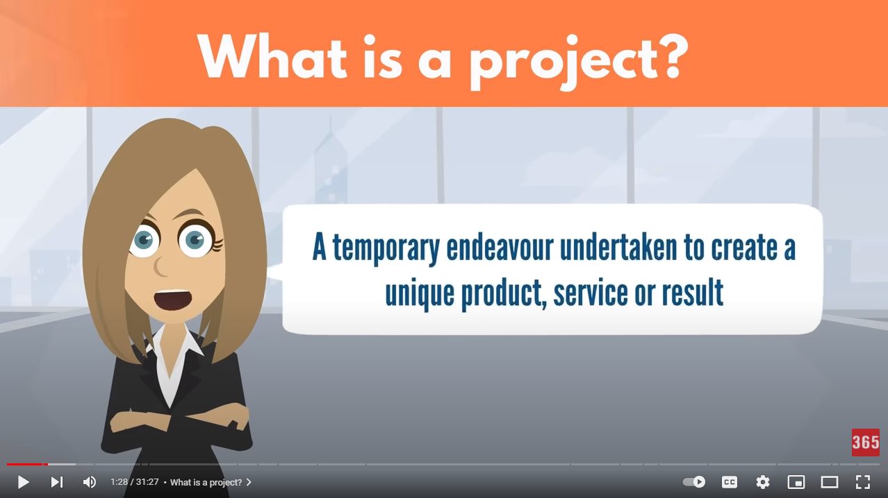

project need you make a big effect in order to achieve a unique or specific goal… 

project need show start date or time and finish date or time

## Please put your learning notes here:

## Project management basic

## Project management History

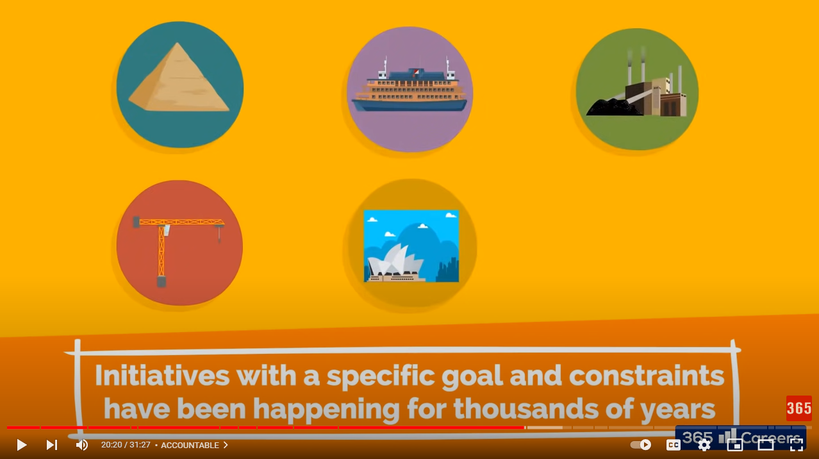

Good example is: Ancient Egypt build a big project!

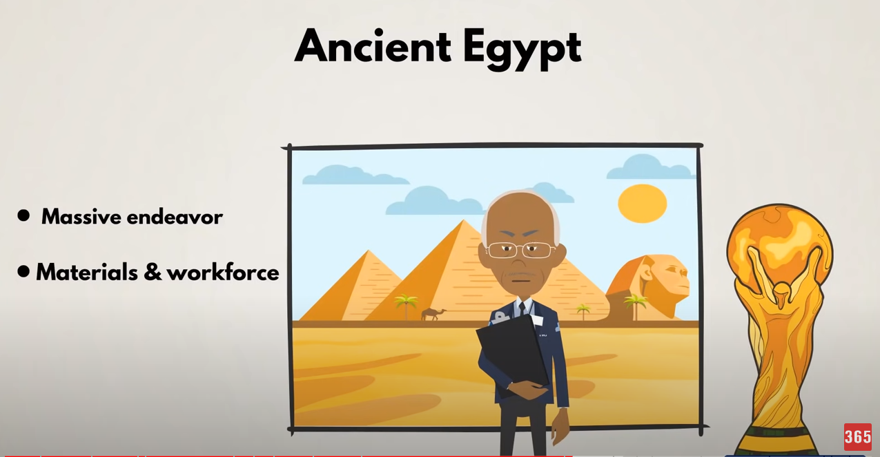

20 Century the Henry Gantt first make Gantt Chart Diagram. It is the revolution to know more about project management.

## Project management in the future

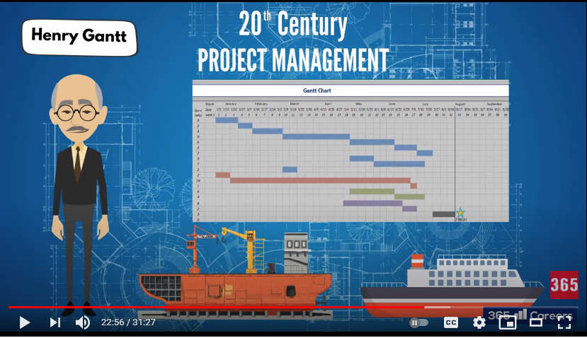

## Project Team

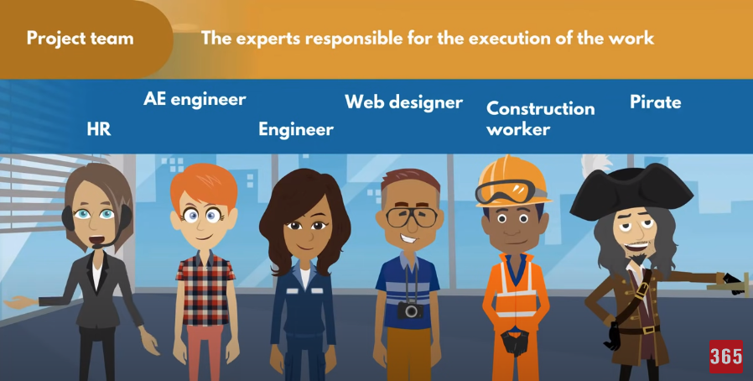

The experts responsible for the execution of the work

## Document Search Index

A

**analytical** **5**

C

**communication** **3**, **5**, **7**

D

**development** **3**, **8**

G

**goals** **4**, **6**, **7**, **8**

M

**management** **1**, **2**, **3**, **5**, **6**, **7**, **9**, **12**, **13**

**mission** **4**

O

**observation** **4**, **5**

organization **3**, **4**, **6**, **7**, **8**

P

**project** **1**, **2**, **3**, **4**, **6**, **7**, **8**, **9**, **10**, **11**, **12**

**projects** **3**, **4**, **6**

R

**resources** **2**, **3**, **4**, **8**

**risk** **5**, **6**, **8**

S

**stakeholder** **2**, **3**, **7**

**strategies** **4**, **5**